Revision History
Date | Version | Description | Author
14/11/25 | 1.1 | Created and added Software Architecture Overview diagram. | Alp Eren Erdur, Tuna Özen
15/11/25 | 1.2 | Created and added GUI component diagrams and workflows . | Alp Eren Erdur, Tuna Özen, Özgür Yılmaz, Murad Seyfullayev
16/11/25 | 1.3 | Created and added User Management’s and Database’s component interfaces, component diagrams, workflows and algorithms | Özgür Yılmaz
17/11/25 | 1.4 | Created and added Appointment System’s and Hospital Management’s component interfaces, component diagrams, workflows and algorithms. | Alp Eren Erdur, Tuna Özen, Murad Seyfullayev
17/11/25 | 1.5 | Organized the document in order. | Alp Eren Erdur
18/11/25 | 1.6 | Added system requirement mappings to all components | Murat Tuna Özen, Alp Eren Erdur
18/11/25 | 1.7 | Revised database workflow | Murat Tuna Özen, Özgür Yılmaz
25/11/25 | 1.8 | Corrected arrows on component designs and mappings are completed. | Murad Seyfullayev
25/11/25 | 1.9 | Revised workflows and algorithms for user management | Özgür Yılmaz, Murad Seyfullayev
26/11/25 | 2.0 | Revised software architecture design and added COTS identification | Özgür Yılmaz, Murad Seyfullayev

TABLE OF CONTENTS
Revision History 1
1 Introduction 3
1.1 References 3
1.1.1 Project References 3
2 Software Architecture overview 3
3 Software design description 4
3.1 GUI 4
3.1.1 Component interfaces 4
3.1.2 Component design description 4
3.1.3 Workflows and algorithms 4
3.1.4 Software requirements mapping 5
3.2 User Management 5
3.2.1 Component interfaces 5
3.2.2 Component design description 6
3.2.3 Workflows and algorithms 7
3.2.4 Software requirements mapping 10
3.3 Appointment System 11
3.3.1 Component interfaces 11
3.3.2 Component design description 11
3.3.3 Workflows and algorithms 12
3.3.4 Software requirements mapping 12
3.4 Hospital Management 13
3.4.1 Component Interfaces 13
3.4.2 Component Design Description 13
3.4.3 Workflows and algorithms 14
3.4.4 Software requirements mapping 15
3.5 Database 15
3.5.1 Component interfaces 15
3.5.2 Component design description 15
3.5.3 Workflows and algorithms 16
3.5.4 Software requirements mapping 16
4 COTS Identification 17

Introduction

This document describes the design of the HMS software system.

References

Project References

# | Document Identifier | Document Title
[SRS] | HMS-SRS-1.7 | HMS Software Requirements Specifications

Software Architecture overview

Software design description

GUI

Component interfaces
This package implements the graphical user interface of the application. It allows users to interact with other system components through this interface. Consequently, it does not expose any interfaces that must be accessed by other packages.

Component design description
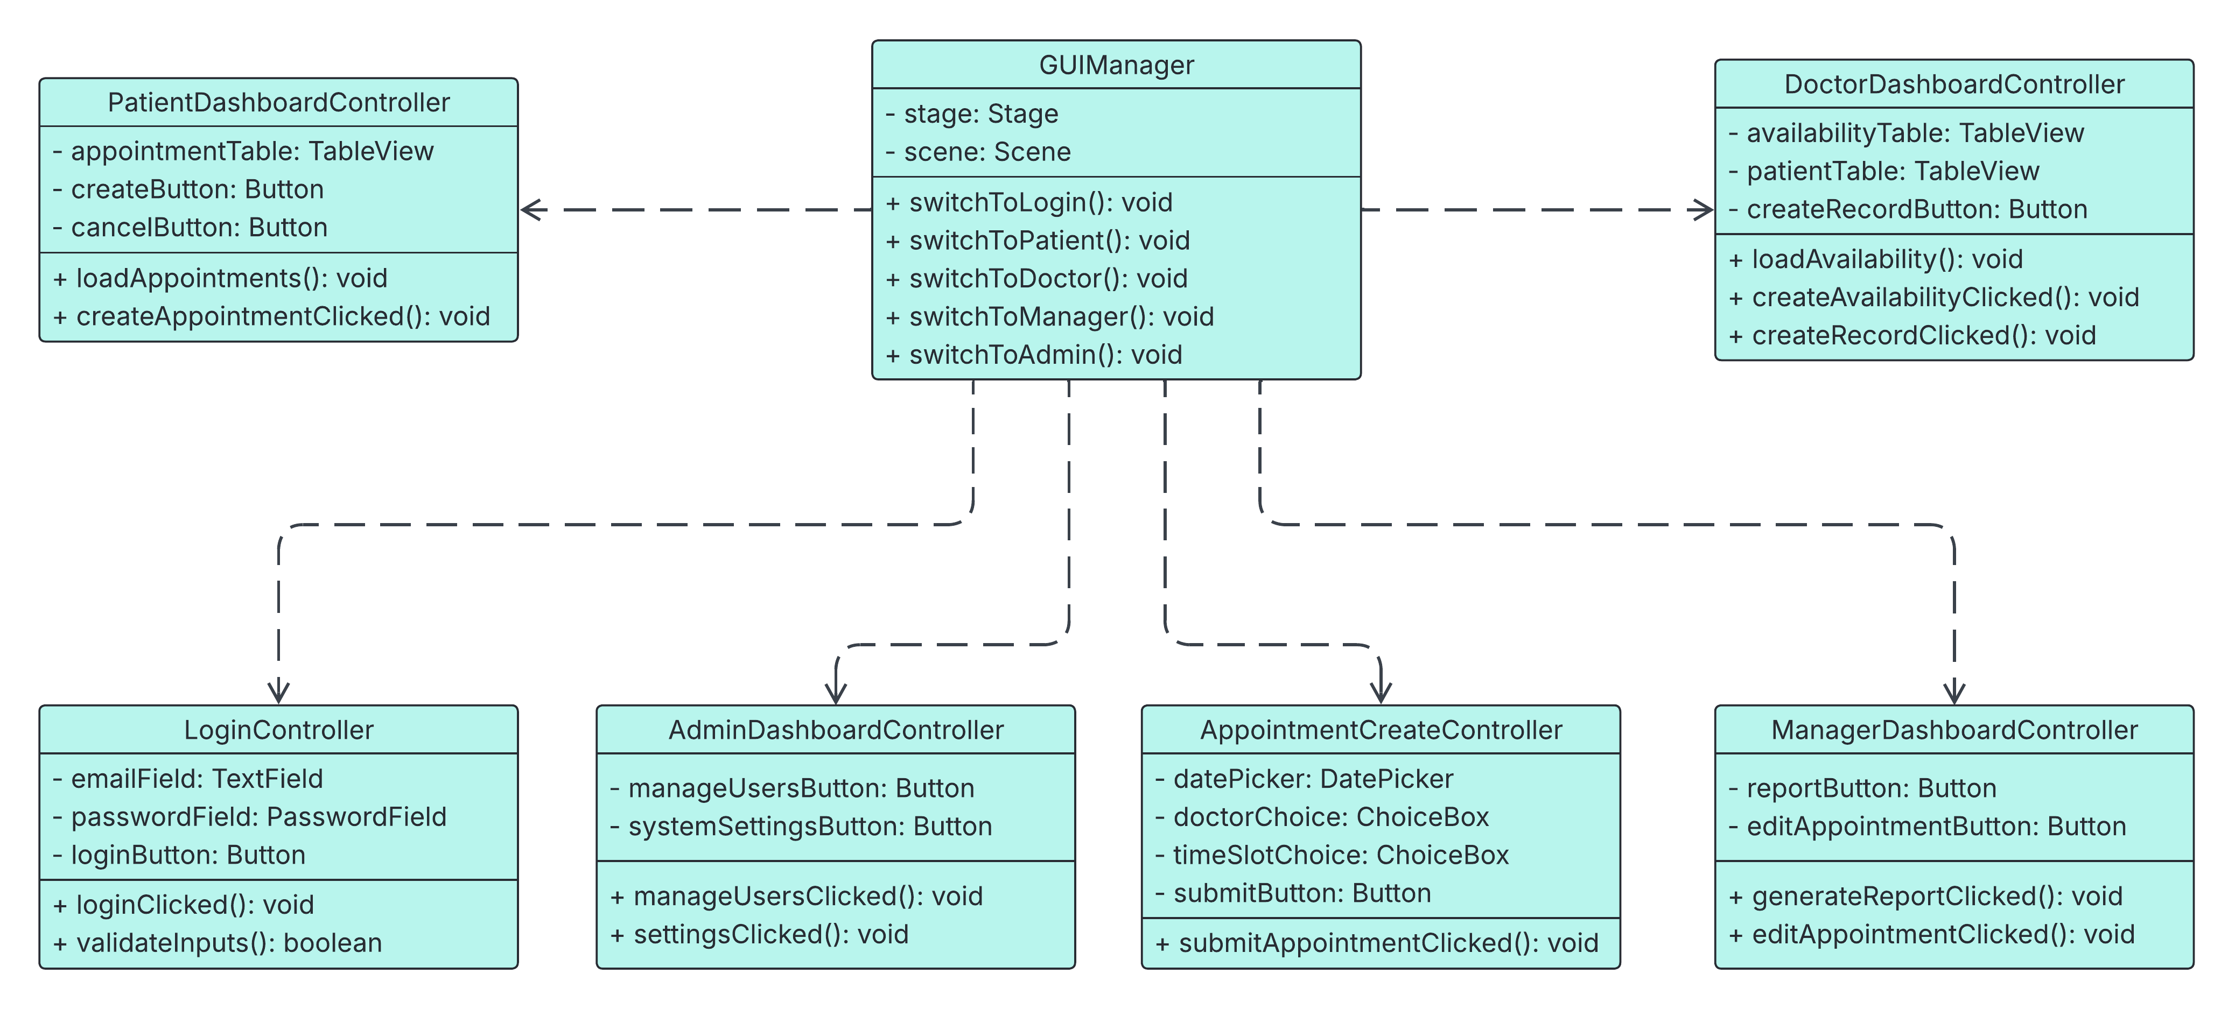

Workflows and algorithms
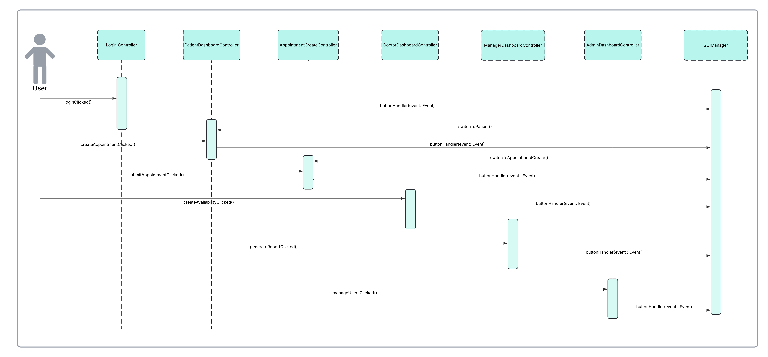

Software requirements mapping
SRS-HMS-001
SRS-HMS-002
SRS-HMS-003
SRS-HMS-004
SRS-HMS-005
SRS-HMS-006
SRS-HMS-007
SRS-HMS-001.1
SRS-HMS-001.2
SRS-HMS-001.3
SRS-HMS-003.2
SRS-HMS-003.3
SRS-HMS-003.4
SRS-HMS-005.1
SRS-HMS-005.3
SRS-HMS-006.4
SRS-HMS-009.1
SRS-HMS-009.2
SRS-HMS-012

User Management

Component interfaces
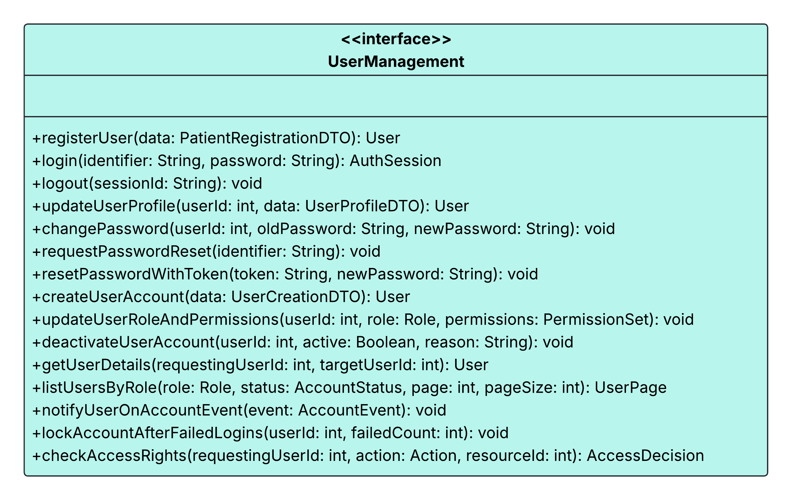

Component design description
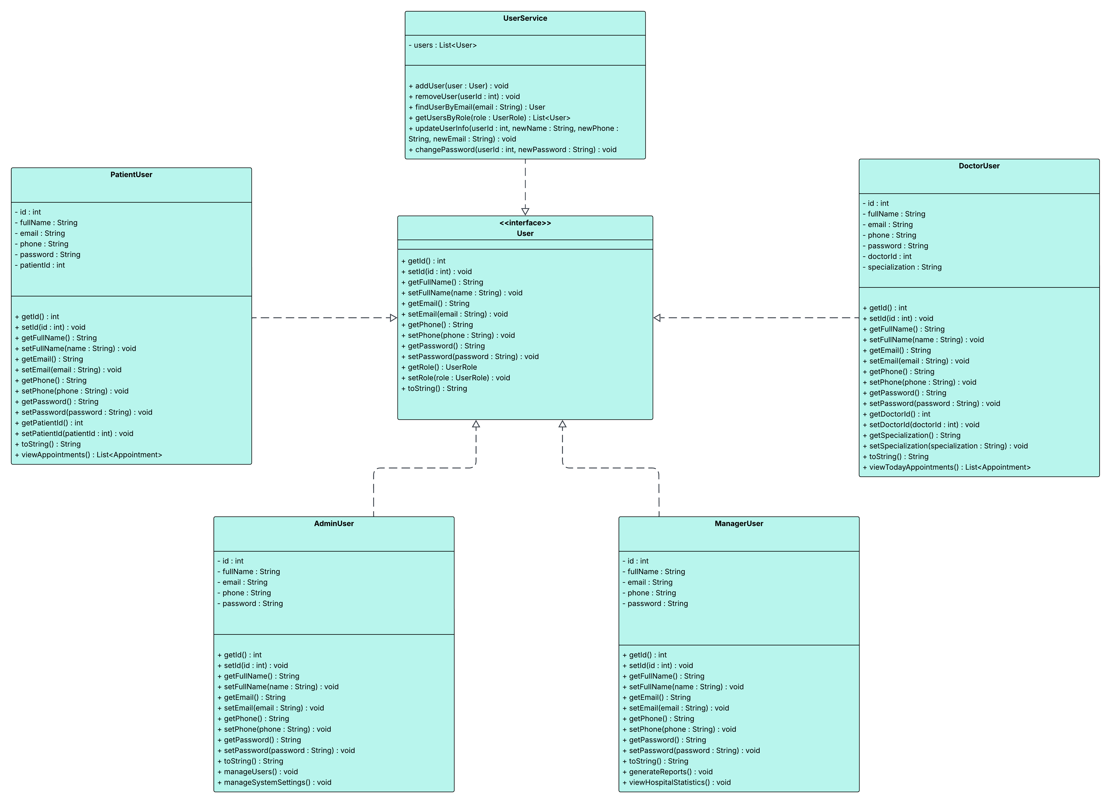

Workflows and algorithms

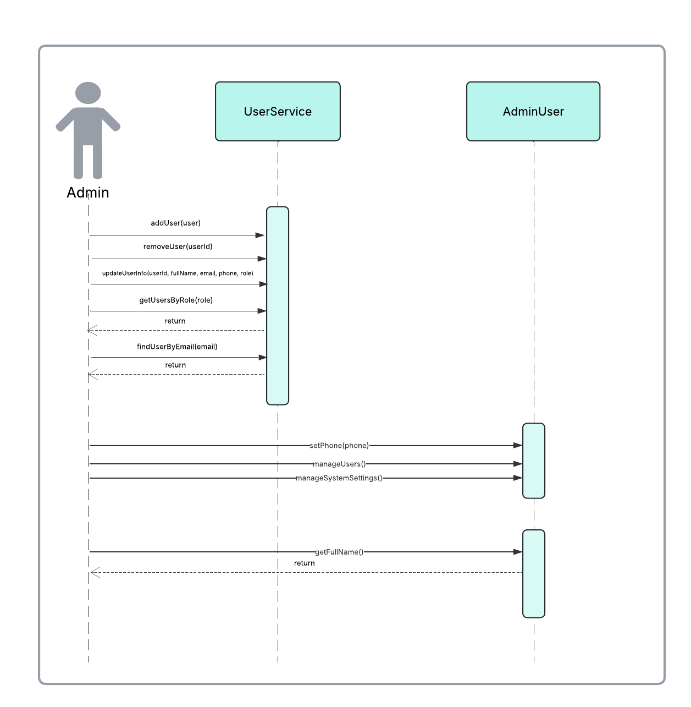
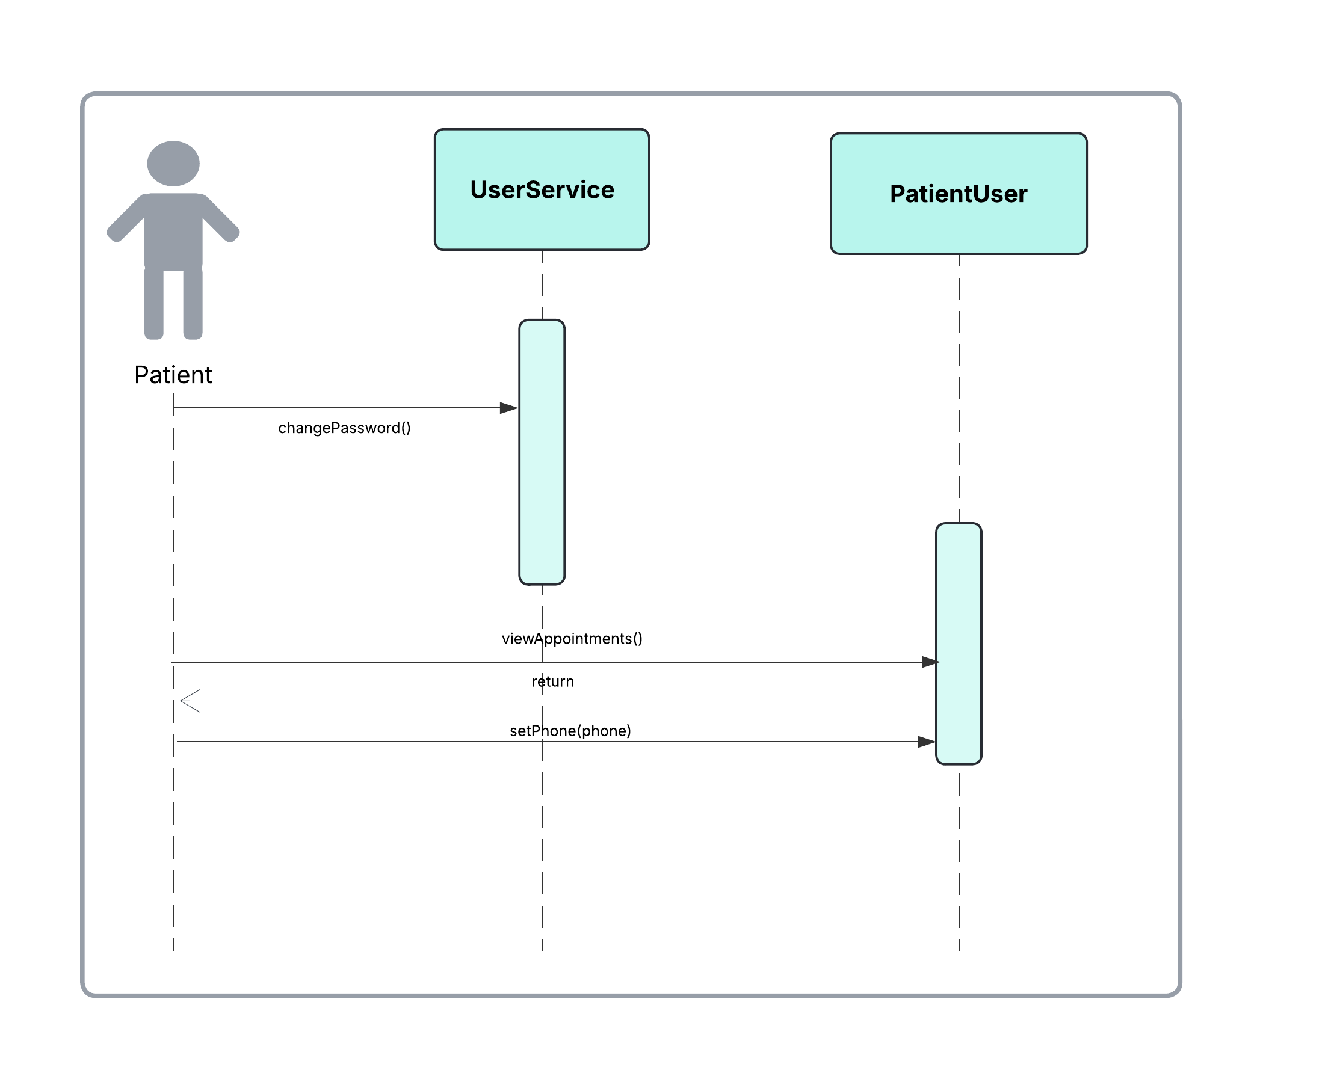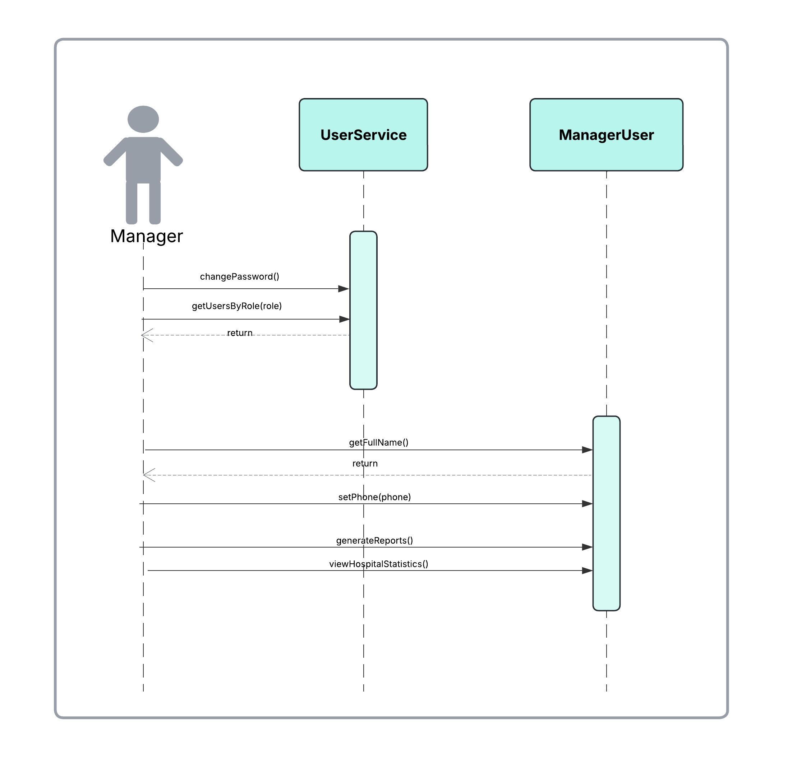
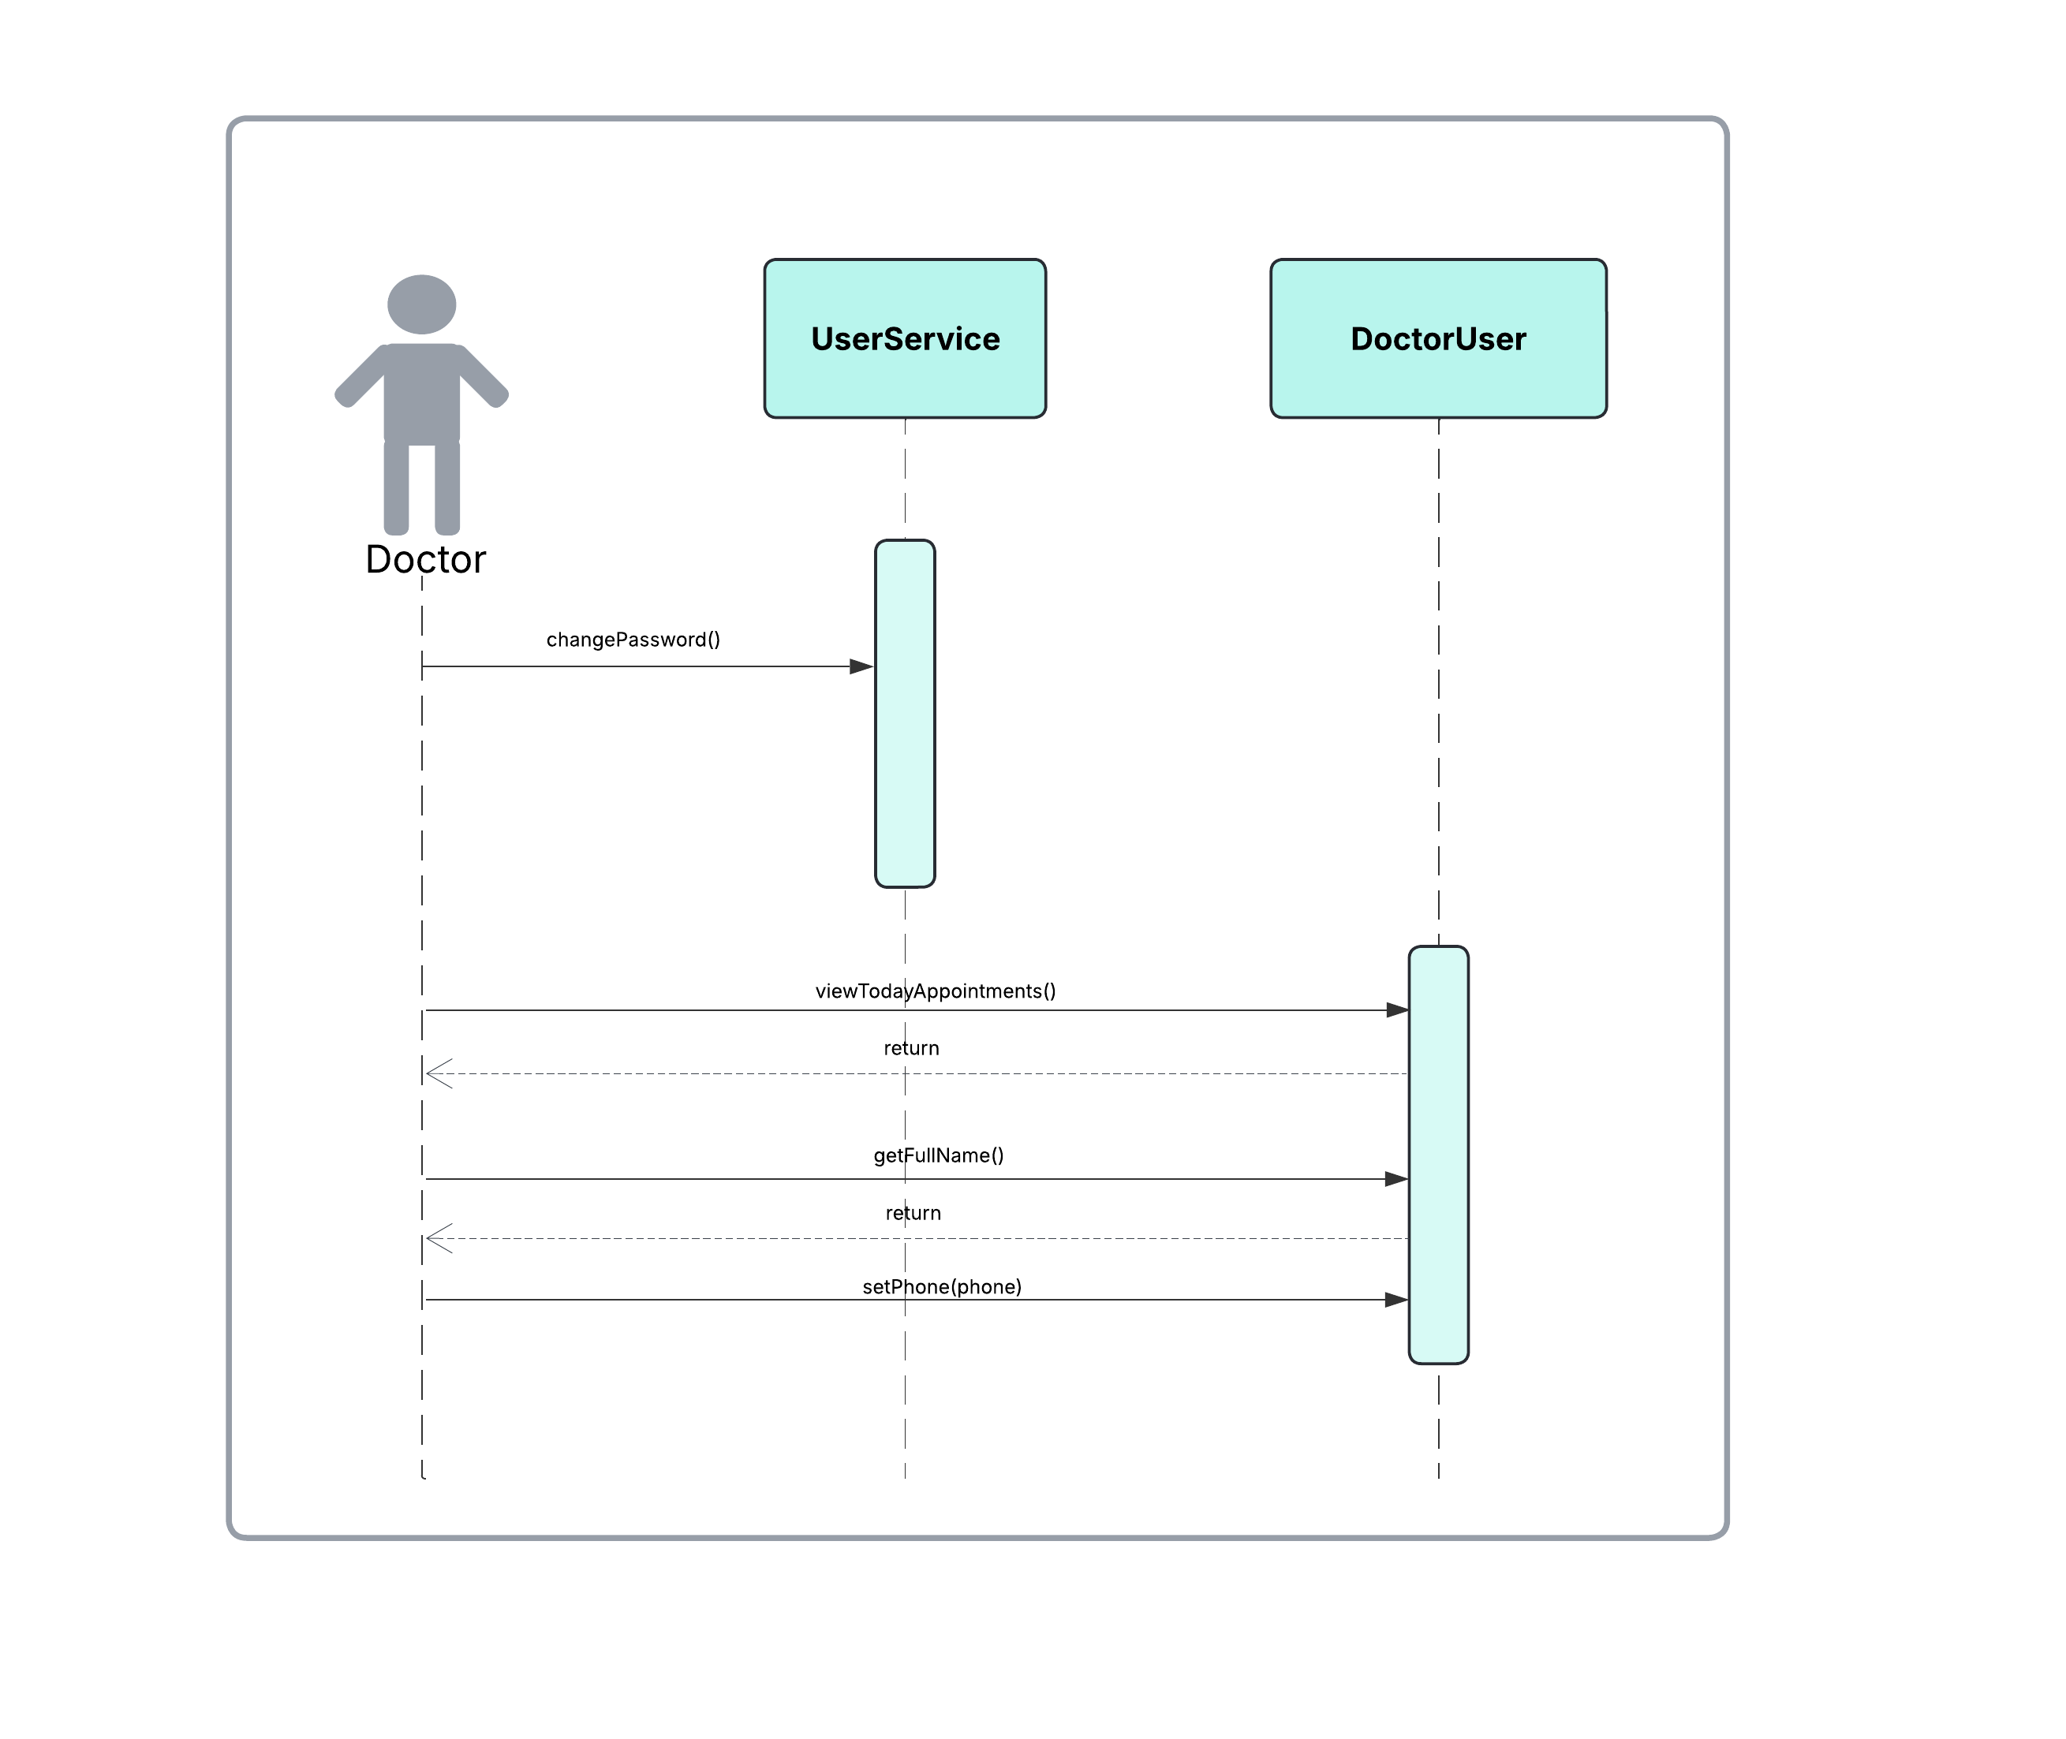

Software requirements mapping
SRS-HMS-001
SRS-HMS-001.1
SRS-HMS-001.2
SRS-HMS-001.3
SRS-HMS-001.4
SRS-HMS-008
SRS-HMS-011
SRS-HMS-012

Appointment System

Component interfaces
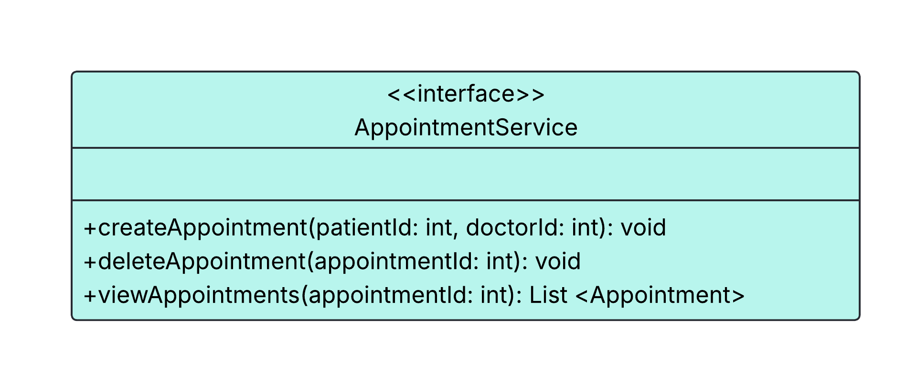

Component design description
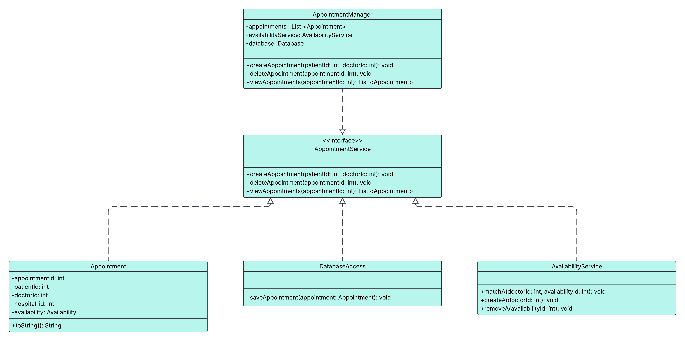

Workflows and algorithms
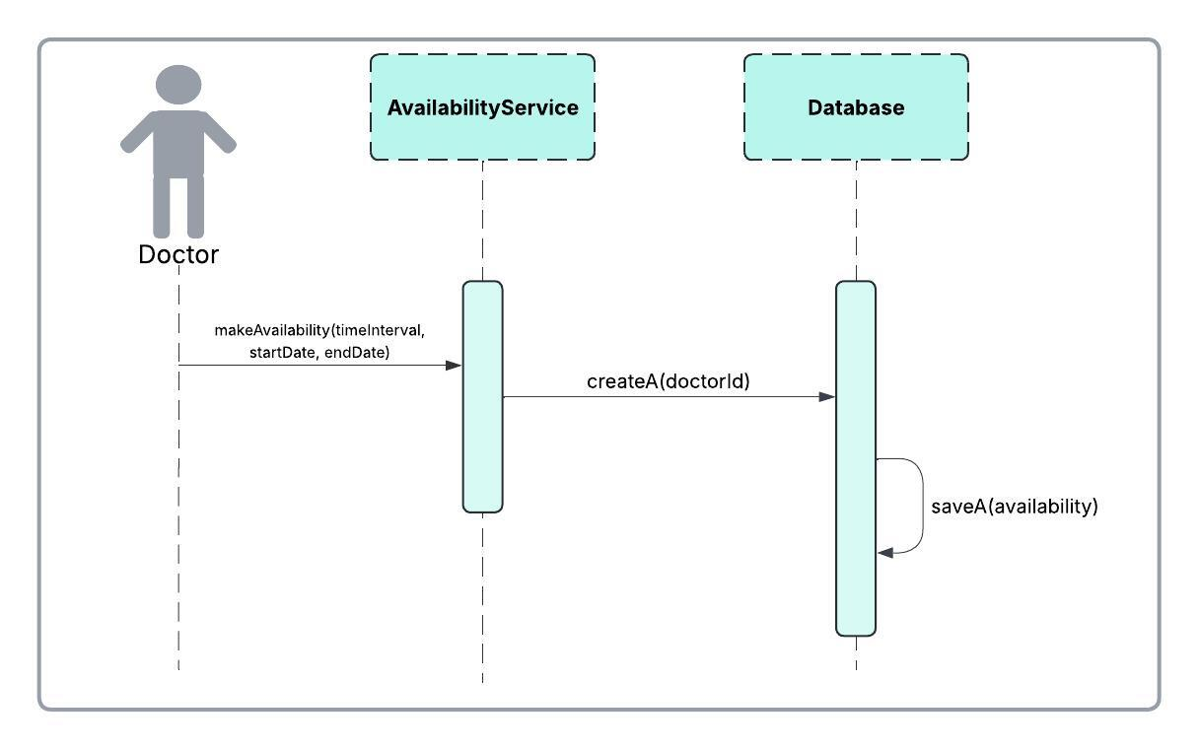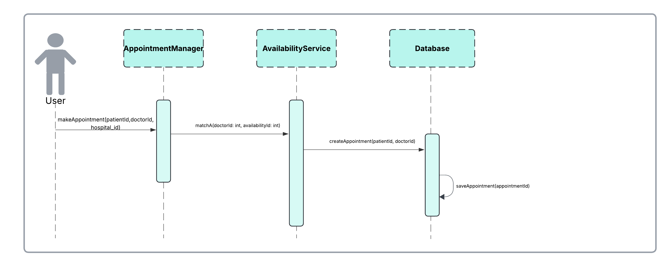

Software requirements mapping
SRS-HMS-002
SRS-HMS-005
SRS-HMS-002.1
SRS-HMS-002.2
SRS-HMS-002.3
SRS-HMS-002.4
SRS-HMS-002.5
SRS-HMS-006
SRS-HMS-009
SRS-HMS-012

Hospital Management

Component Interfaces
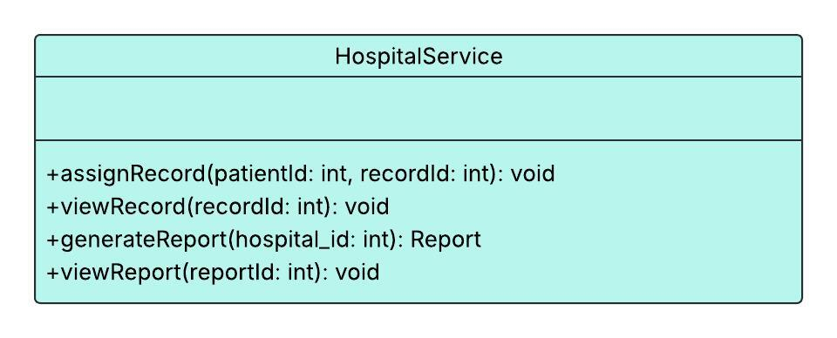

Component Design Description

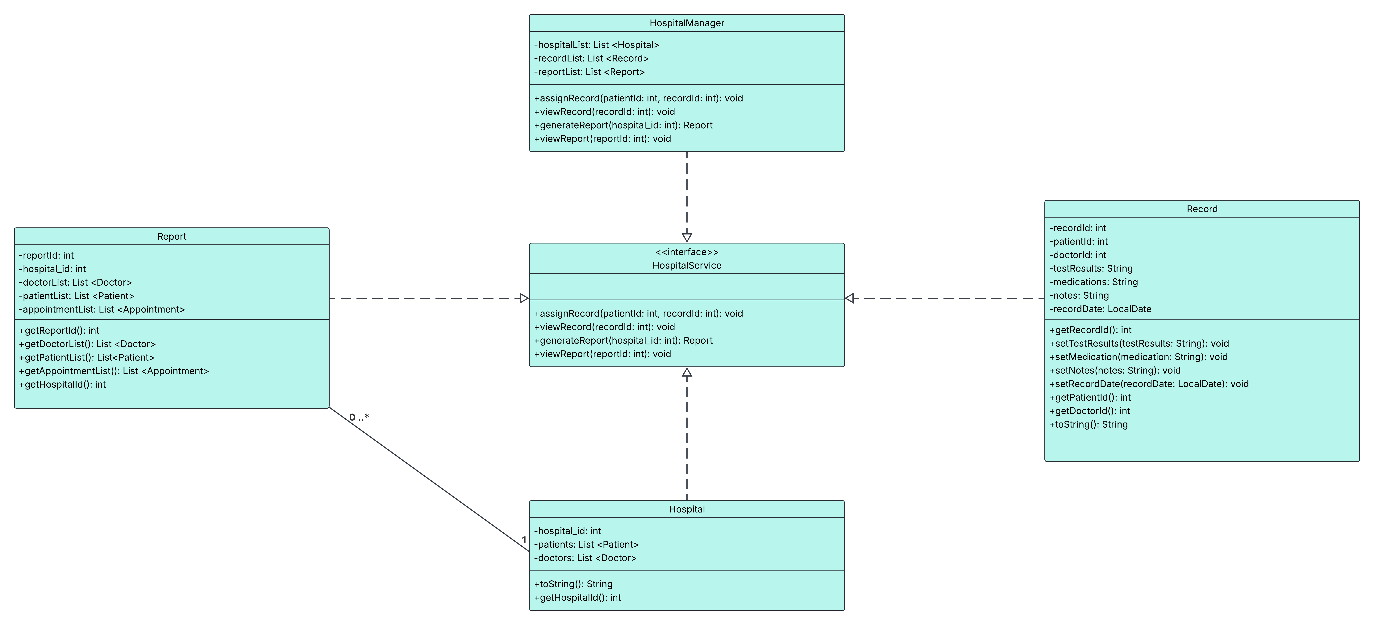

Workflows and algorithms
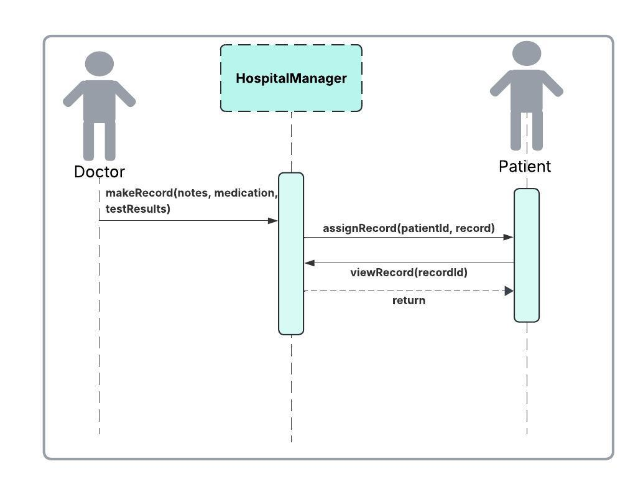
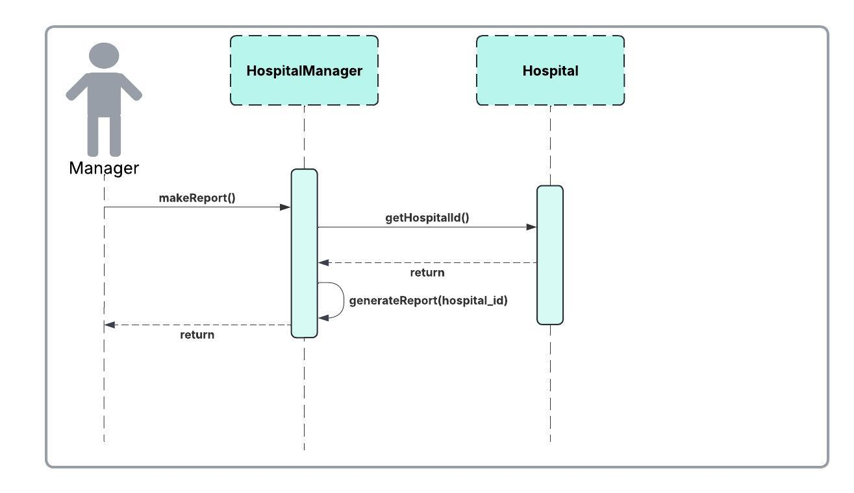

Software requirements mapping
SRS-HMS-003
SRS-HMS-008
SRS-HMS-009
SRS-HMS-010
SRS-HMS-007.1
SRS-HMS-007.2
SRS-HMS-007.3
SRS-HMS-008
SRS-HMS-009
SRS-HMS-010

Database

Component interfaces

Component design description
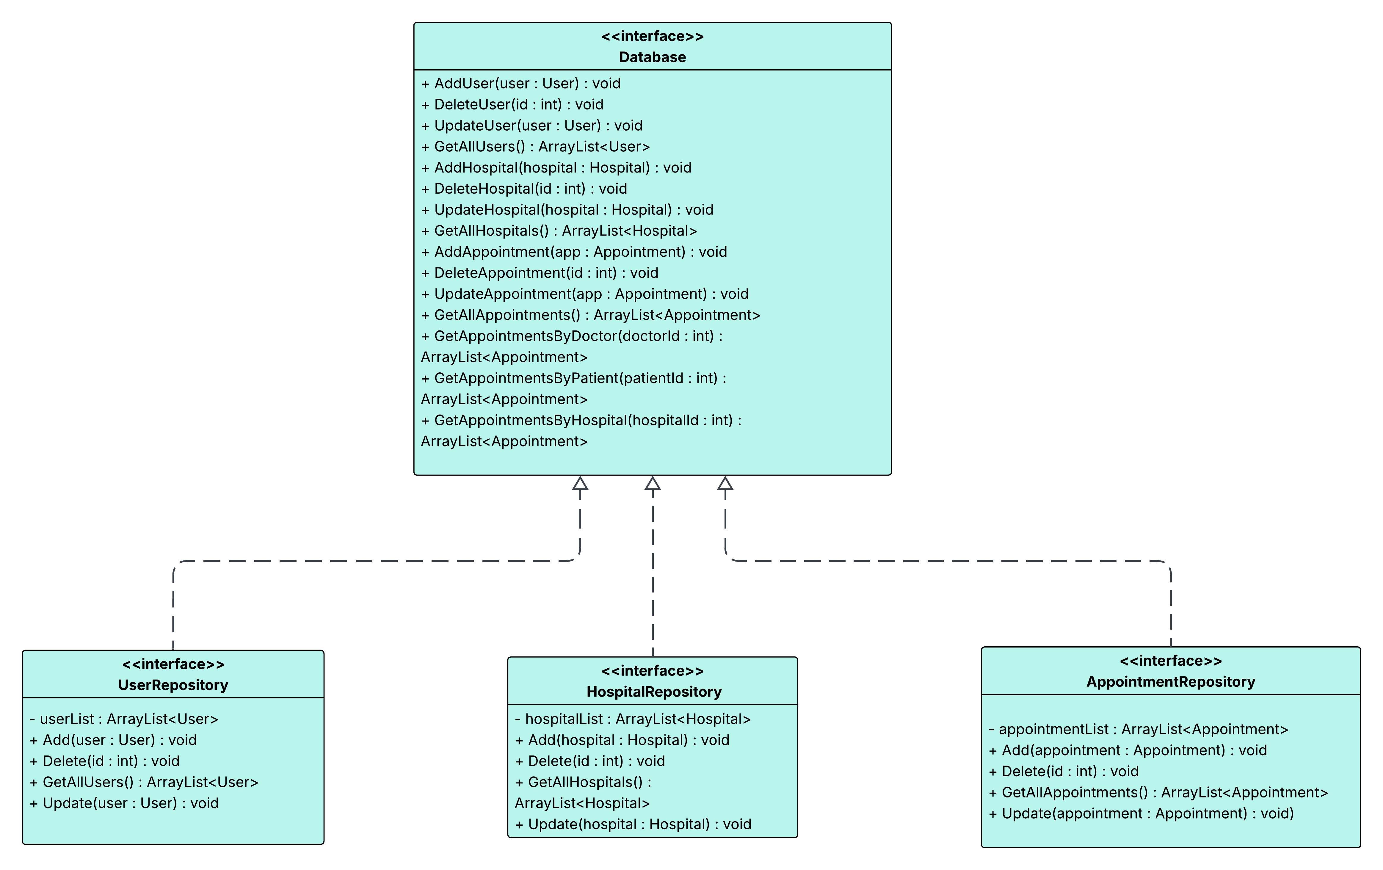

Workflows and algorithms
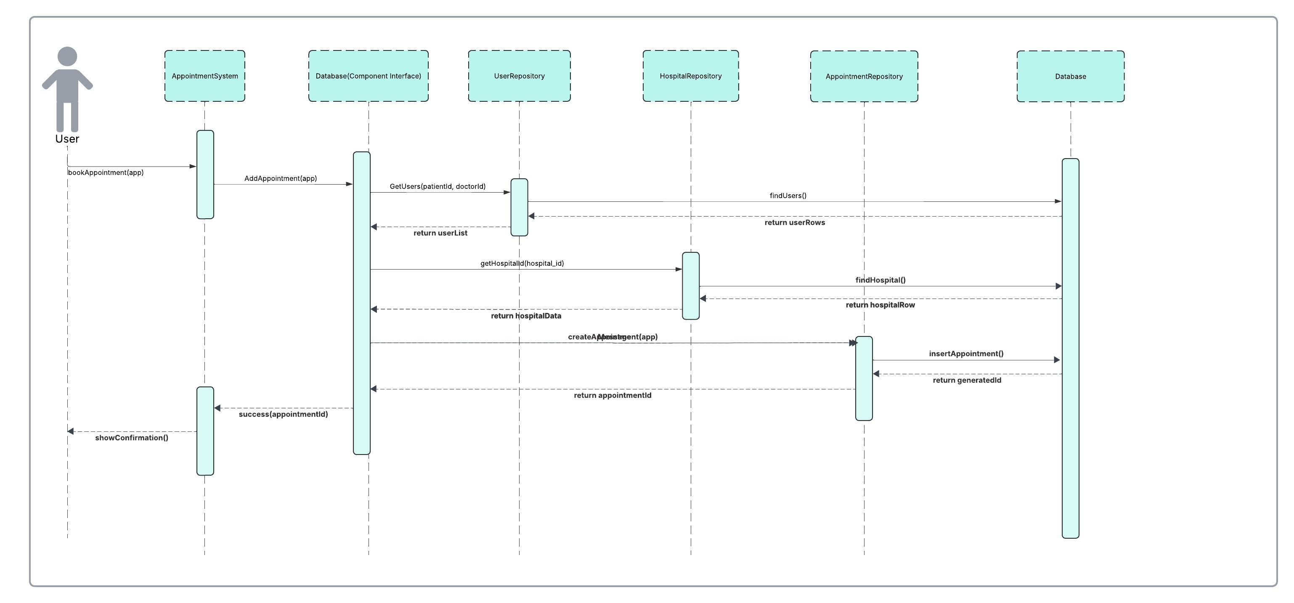

Software requirements mapping
SRS-HMS-001
SRS-HMS-002
SRS-HMS-003
SRS-HMS-004
SRS-HMS-005
SRS-HMS-007
SRS-HMS-001.1
SRS-HMS-003.1
SRS-HMS-003.2
SRS-HMS-004.4
SRS-HMS-006.2
SRS-HMS-006.3
SRS-HMS-006.4
SRS-HMS-008.1
SRS-HMS-008.2
SRS-HMS-008.3
SRS-HMS-009.3
SRS-HMS-011
SRS-HMS-013

COTS Identification
- JavaFX, https://openjfx.io/
- Java 21, https://docs.oracle.com/en/java/javase/

